Case report. Infected 4th-degree burn in the occipital region of the head

Description | Treatment day 1 |  | Treatment day 2
Patient: 28 year-old man  Associated diseases:  drug abuse  Cause of the wound:  Prolonged contact with a hot radiator (in a drunken state). 14 days of self-treatment with liniment Vishnevsky  Wound size: 10 х 10 cm  Depth: 1.0 cm  Diagnosis: Infected 4th-degree burn in the occipital region (the occipital bone is at the bottom of the wound). Cervical lymphoadenitis.  Standard treatment period:  150-180 days  Prognosis:  Inpatient treatment, autoplasty  Result: Patient refusal of grafting, accelerated healing (80 days) | 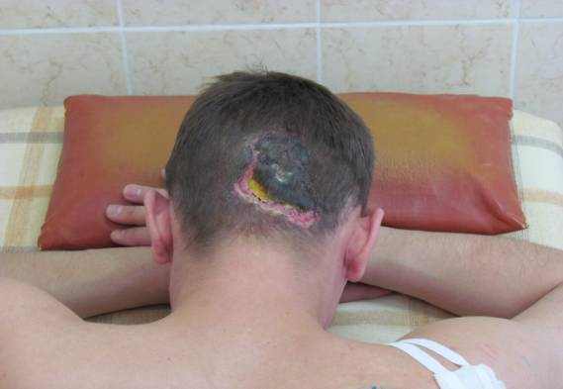 | 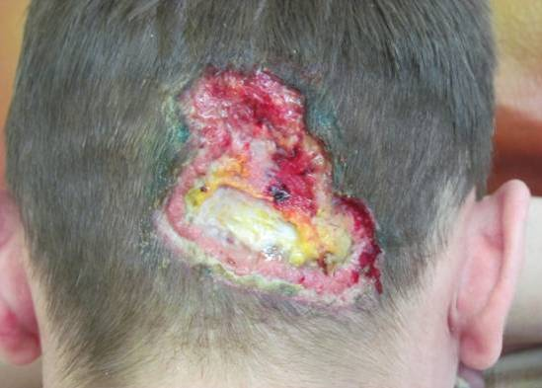 | 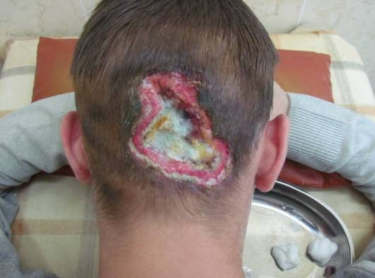
 | Wound assessment: a large wound in the occipital region covered with necrotizing skin with a high level of blue-colored, foul-smelling purulent discharge (the microbiological analysis revealed a polyresistant strain of Pseudomonas aeruginosa). | Wound care:  Surgical wound debridement (necrectomy, antispetic irrigation with 3% hydrogen peroxide and furacillin).  A dressing VitaVallis is applied. | Wound assessment:  Necrectomy. The occipital bone is at the bottom of the wound.  Wound care: antiseptic irrigation with 3% hydrogen peroxide and furacillin.  A dressing VitaVallis is applied.
 | Treatment day 3 | Treatment day 4 | Treatment day 7
 | 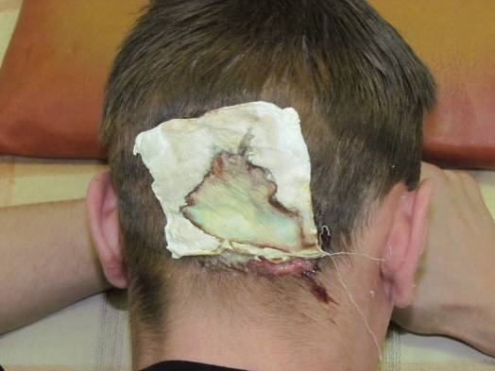 | 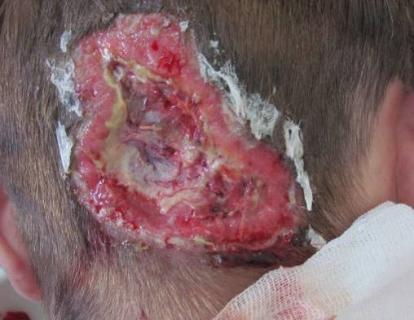 | 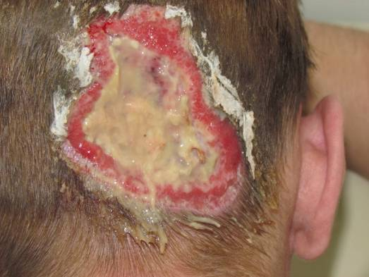
 | Wound assessment:  The dressing is imbibed with pus (the microbiological analysis revealed a polyresistant strain of Pseudomonas aeruginosa)  Wound care: The discharge of pus continues, the wound granulates at the edges.  A dressing VitaVallis is applied. | Wound assessment:  The wound size is reduced owing to the granulation tissue growth at the wound edges. The necrotic tissue rejection continues at the bottom of the wound.  Wound care:  Necrectomy back to bleeding tissue. Antiseptic irrigation with 3% hydrogen peroxide and furacillin.  A dressing VitaVallis with Levomekol ointment is applied and left in place for 2 days. | Wound assessment:  Acute rejection of necrotic tissue  Wound care:  Mechanical removal of detritus. Antiseptic irrigation with 3% hydrogen peroxide and furacillin. A dressing VitaVallis is applied.
 | Treatment day 8 | Treatment day 11 | Treatment day 15
 | 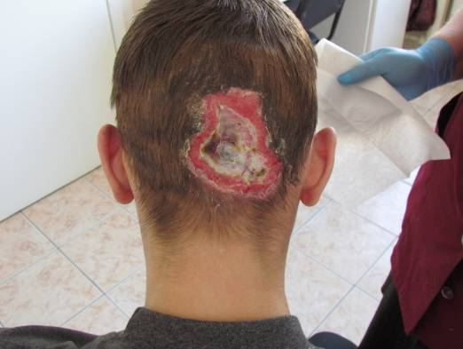 | 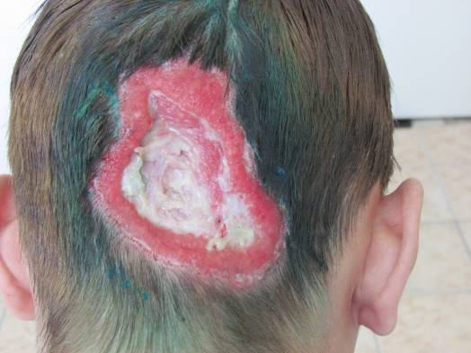 | 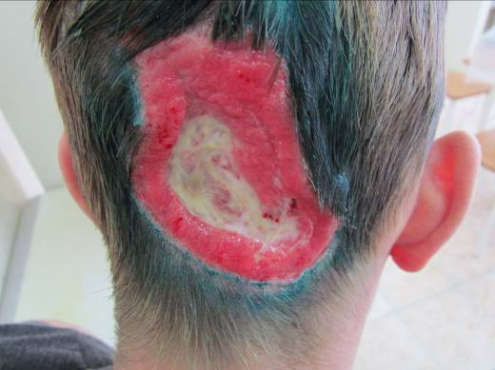
 | Wound assessment:  The wound is clean and granulates from the bottom. The microbiological analysis revealed saprophytic flora.  Wound care:  Antiseptic irrigation with 3% hydrogen peroxide and furacillin. A dressing VitaVallis is applied. | Wound assessment:  The wound is absolutely clean, actively granulates and uniformly contracts.  Wound care:  Antiseptic irrigation with 3% hydrogen peroxide and furacillin. A dressing VitaVallis is applied. | Wound assessment:  The wound actively granulates and uniformly contracts.  Wound care:  Antiseptic irrigation with furacillin. A dressing VitaVallis is applied.
 | Treatment day 32 | Treatment day 53 | Treatment day 57
 | 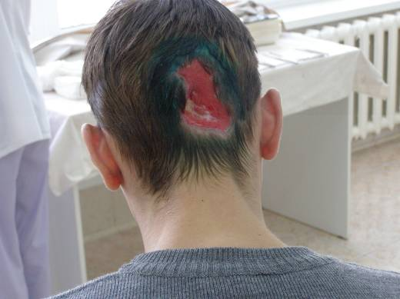 | 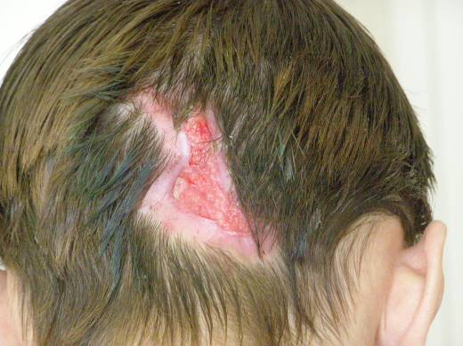 | 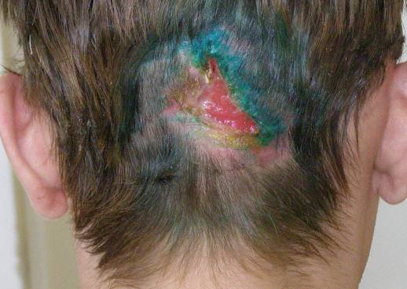
 | Wound assessment:  The wound actively granulates and uniformly contracts.  Wound care:  Antiseptic irrigation with furacillin. A dressing VitaVallis is applied. | Wound assessment:  Considerable contraction of the wound. Epithelization of the edges. Active granulation at the bottom of the wound.  Wound care:  Antiseptic irrigation with furacillin. A dressing VitaVallis is applied. | Wound assessment:  Wound epithelization  Wound care:  Antiseptic irrigation with furacillin. A dressing VitaVallis is applied.
 | Treatment day 60 | Treatment day 66 | Treatment day 72
 | 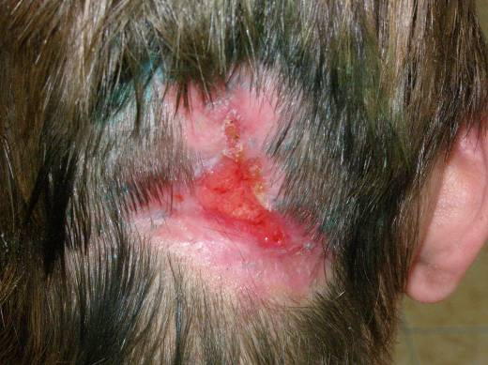 | 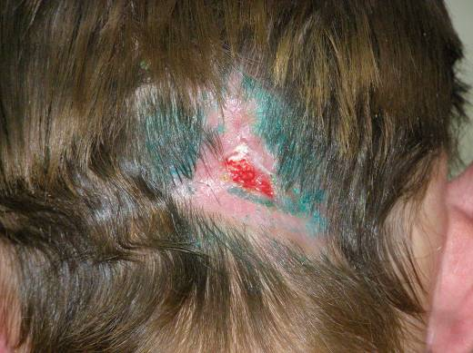 | 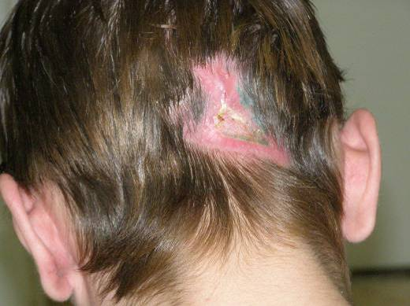
 | Wound assessment:  Wound epithelization  Wound care:  Antiseptic irrigation with furacillin. A dressing VitaVallis is applied. | Wound assessment:  Contraction of the wound edges. Wound heling from the bottom up.  Wound care:  Antiseptic irrigation with furacillin. A dressing VitaVallis is applied. | Wound assessment:  Complete epithelization  Wound care:  A dressing VitaVallis is applied.
 | Treatment day 80
 | 