Case report. Recurrent erysipelas of the legs

Description | Treatment day 1 | Treatment day 31 | 1 month after discharge
Patient: 90-year-old woman  Diagnosis:  Recurrent erysipelas of the legs  Result: Wound healing by secondary intention | 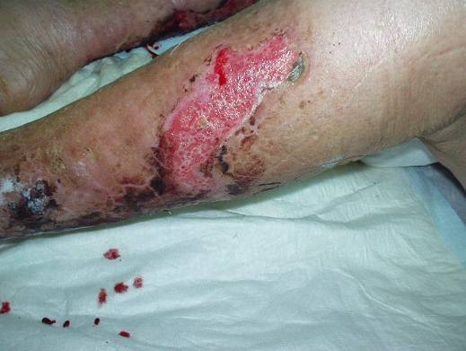 | 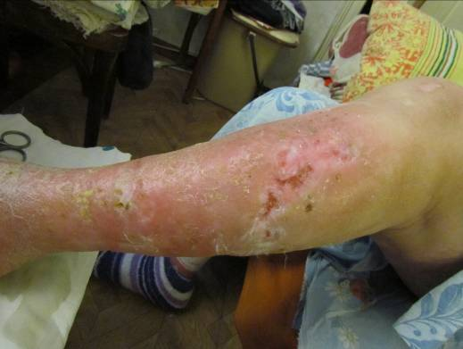 | 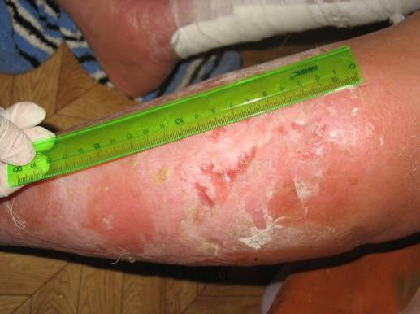
 | Wound assessment:  After removal of necrotic skin there is a wound 15 by 6 cm in size. Granulation tissue, fibrin and purulent discharge are present in the wound.  Wound care:  A dressing VitaVallis is applied. | Wound assessment:  The wound is clean, epithelization and healing by secondary intention take place, leg swelling went down.  Wound care:  A dressing VitaVallis is applied. | Wound assessment:  One month after discharge from hospital the wound healed by secondary intention.

