Case report. Third degree burn on the lower right leg

Description | Treatment day 1 | Treatment day 2 | Treatment day 4
Patient: 45-year-old man  Wound size:  Distal area12 х 5 cm  Depth: 0.5 cm  Proximal area: 18 х 9 cm  Depth: 0.7 cm  Diagnosis: 3d degree burn on the lower right leg (flame burn)  Prognosis: Long-term healing and rough scarring  Result: Accelerated healing, minimal scarring | 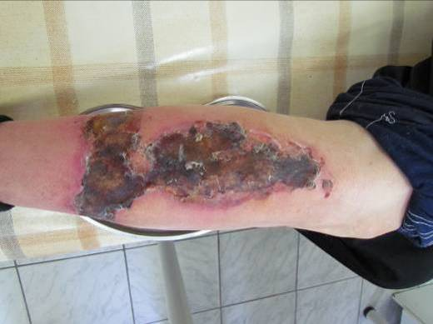 | 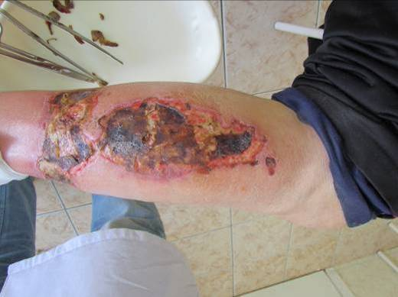 | 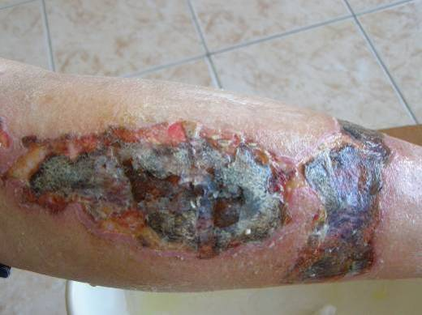
 | Wound assessment:  The wound is covered with a dry scab, shows perifocal inflammation and purulent discharge. The proximal part of the wound is covered with a dressing VitaVallis, and the distal part with a furacilin saturated gauze dressing.  Wound care:  Wound irrigation with 3% hydrogen peroxide and furacillin,  VitaVallis dressing application. | Wound assessment:  Reduction of pain and perifocal inflammation in the proximal part of the wound, no discharge. In the distal part (under the gauze) inflammation and pain persist, necrectomy cannot be performed because of hard scabs present. In the proximal part necrectomy is performed at the periphery.  Wound care:  Necrectomy,  Wound irrigation with 3% hydrogen peroxide and furacillin,  VitaVallis dressing application. | Wound assessment:  Edge granulation in the proximal part of the wound, no inflammation and discharge on the whole wound surface.  Wound care:  Wound irrigation with 3% hydrogen peroxide and furacillin,  VitaVallis dressing application.
 | Treatment day 15 | Treatment day 30 | Treatment day 35
Microbiological analysis of wound discharge  Heterogeneous microflora (Gr+ and Gr-) sensitive to ciprofloxacin, lincomycin, imipenem, and resistant to cefotaxime and ceftriaxone | 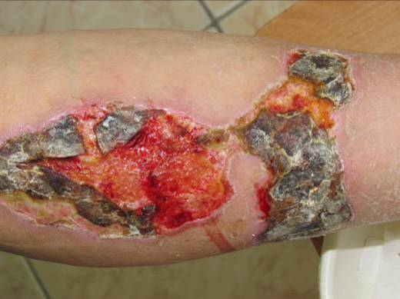 | 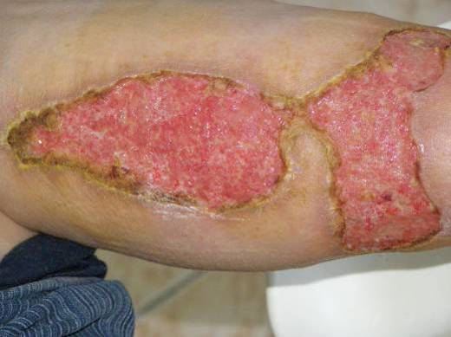 | 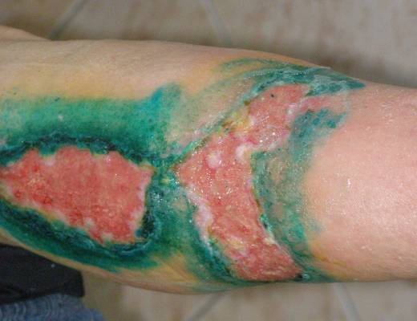
 | Wound assessment:  Necrectomy in the proximal part of the wound, in the distal part necrectomy is performed on a small area only because of hard scabs.  Wound care:  Necrectomy,  Wound irrigation with 3% hydrogen peroxide and furacillin,  VitaVallis dressing application. | Wound assessment:  The wound is free from scabs and granulates actively. In the proximal part the granulation surface is smooth with epithelialized areas.  Wound care:  The wound is irrigated with 3% hydrogen peroxide and furacillin,  then treated with Olazol spray.  A dressing VitaVallis is applied. | Wound assessment:  The proximal part of the wound contracts and epithelializes more rapidly and better.  Wound care:  The wound is irrigated with 3% hydrogen peroxide and furacillin. The wound edges are treated with brilliant green.  A dressing VitaVallis is applied.
 | Treatment day 46 | Treatment day 52 | Treatment day 56
 | 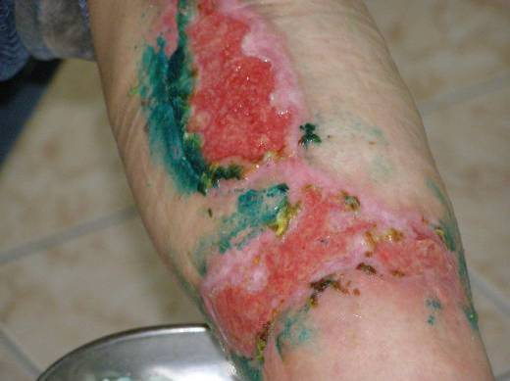 | 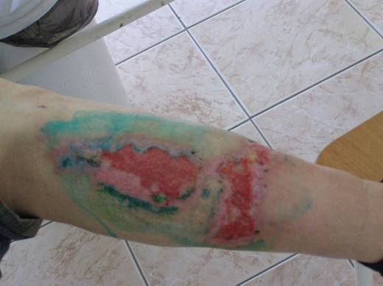 | 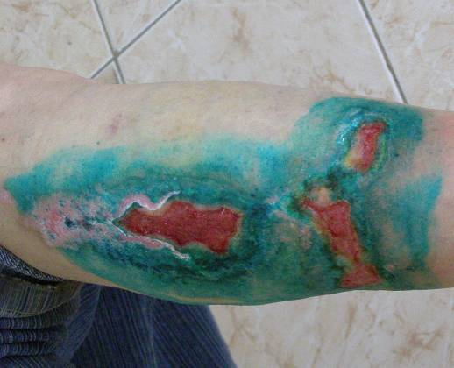
 | Wound assessment:  Edge epithelialization. Wound contraction. Irregular healing from the wound bed in the distal part, and regular in the proximal part.  Wound care:  The wound is irrigated with 3% hydrogen peroxide and furacillin. The wound edges are treated with brilliant green.  A dressing VitaVallis is applied. | Wound assessment:  Edge epithelialization. Wound contraction. Irregular healing from the wound bed in the distal part, and regular in the proximal part.  Wound care:  The wound is irrigated with 3% hydrogen peroxide and furacillin. The wound edges are treated with brilliant green.  A dressing VitaVallis is applied. | Wound assessment:  Edge epithelialization. Wound contraction.

