Case report. Post-thrombophlebitic syndrome, 3d degree chronic venous insufficiency

Description | Treatment day 1 | Treatment day 5
Patient: 65-year-old woman  Associated diseases:  Diagnosis:  Postthrombophlebitic syndrome, 3d degree chronic venous insufficiency. Chronic heart failure  Prognosis:  Usually such ulcers do not clean and are non-healing  Result:  Considerable improvement | 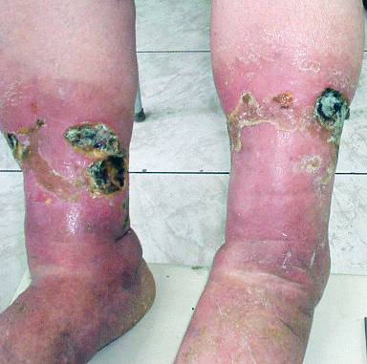 | 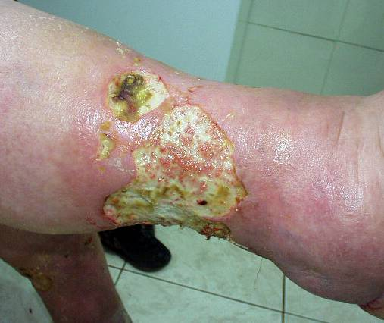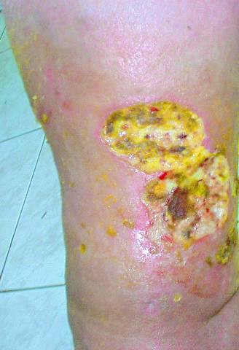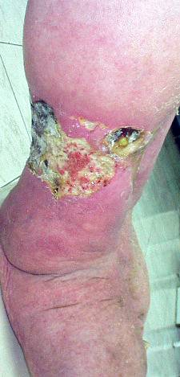
 | Wound assessment:  Foot and leg swelling, skin necrosis  Wound care:  VitaVallis dressing application | Wound assessment:  Removal of skin necrosis, skin defects with pus and fibrin are observed in the hypodermal level.  Wound care:  VitaVallis dressing application
 | Treatment day 30
 | 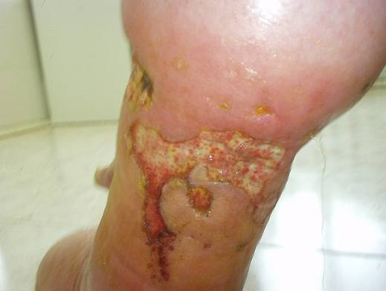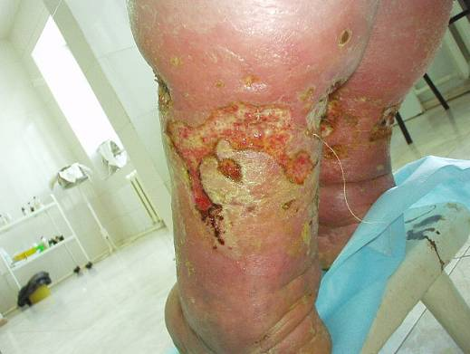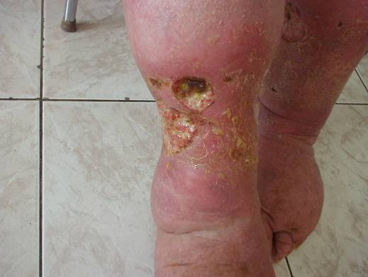
Wound assessment: the wounds are subcutaneous, filled with granulation tissue; contraction and edge epithelialization of defects. Reduction of the foot and leg swelling.

Wound care:
VitaVallis dressing application
 | 1 month treatment-free interval, the patient discharged home from hospital, didn't apply dressings at home
 | 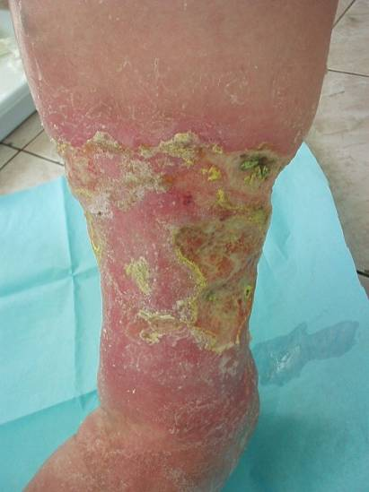 | 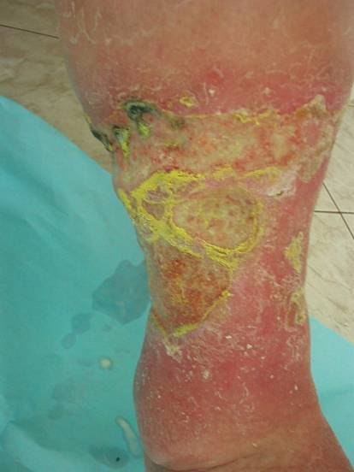 | 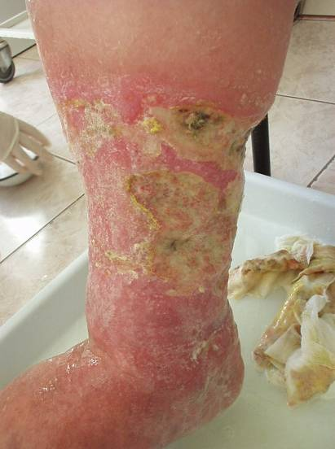
Wound assessment:

Subcutaneous wounds, no dermal and hypodermal necrosis, active granulation, epithelialization of defects.

