Hemostatic effect
The application of dressings VitaVallis produces a pronounced hemostatic effect. Hemostasis in capillary bleeding is achieved within 1.5-2 minutes. With conventional dressings capillary bleeding stops within 15-20 min.

Nail wedge resection with the excision of hypergranulation tissue around an ingrown nail of the right big toe
After surgery | 1 minute  after VV dressing application | 1.5 minutes  after VV dressing application | 2 minutes  after VV dressing application
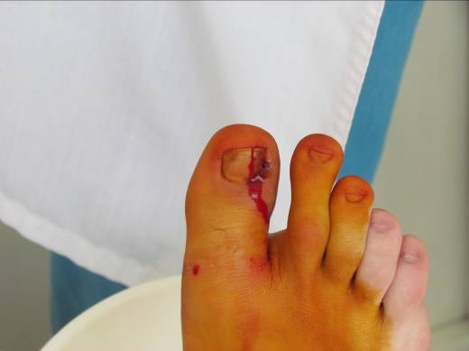 | 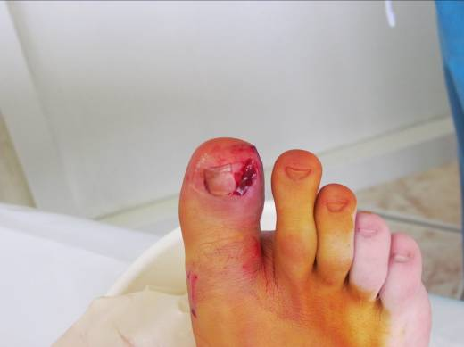 | 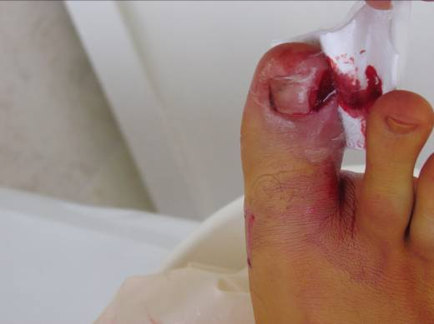 | 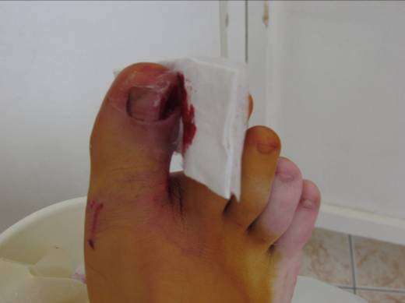
Wound assessment:  Bleeding right after intervention | Wound assessment:  The blood flow is reduced, capillary bleeding continues | Wound assessment:  The blood flow is reduced, capillary bleeding continues | Wound assessment:  Hemostasis is achieved

VitaVallis dressing application for parenchymal hemorrhage arrest in liver resection
Parenchymal hemorrhage | VitaVallis dressing application | 1 minute later | Dressing type
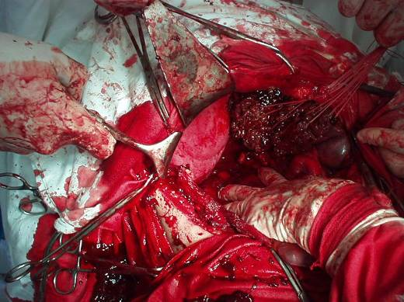 | 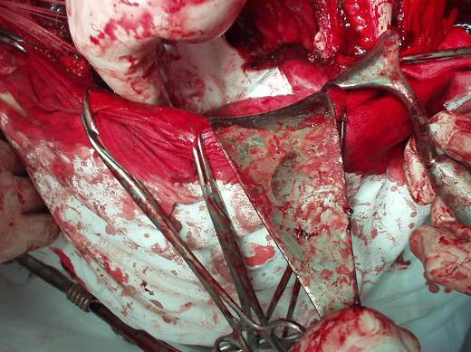 | 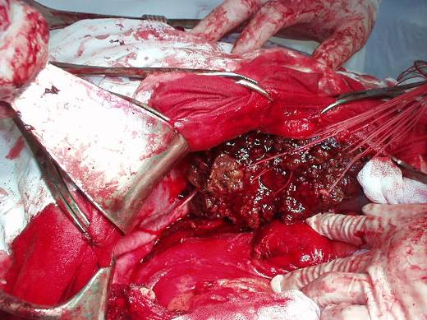 | 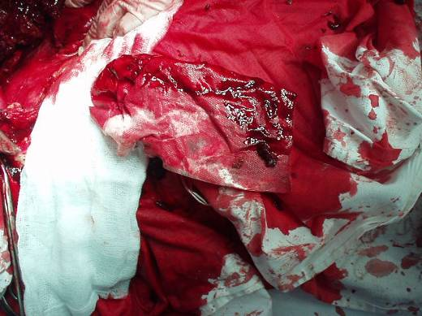
Description:
Surgical removal of the tumor in the right hepatic lobe, tumor resection by the method of B.I. Alperovich. Diffuse parenchymal hemorrhage is arrested by VitaVallis dressing application for 1.5 minutes. The dressing is completely saturated with blood. Then, liver cryoablation is performed along the resection line.

Onychectomy with the resection of a hypertrophic lateral nail fold
 | After surgery | 1 minute later | 24 hours later
Case description:  Patient: 19-year-old woman, long suffering from an ingrown nail of the right big toe. Conservative treatment had no positive effect. Surgical treatment is performed: onychectomy with the resection of a hypertrophic lateral nail fold | 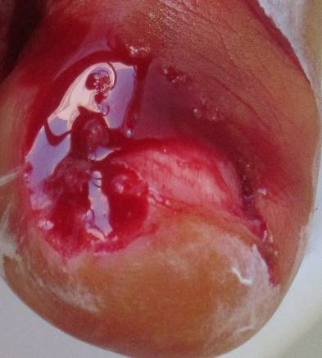 | 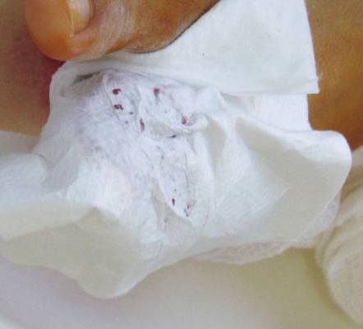 | 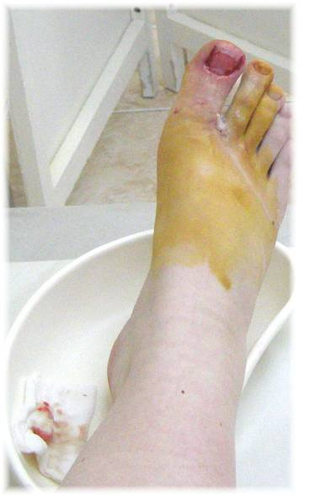
 | Wound assessment:  The removal of the nail plate and lateral nail fold led to capillary bleeding  Wound care:  Hemostasis is achieved by VitaVallis dressing application | Wound assessment:  60 sec after the VitaVallis dressing application the dressing is slightly saturated with blood, capillary bleeding is arrested.  Wound care:  The dressing is fixed with a gauze bandage | Wound assessment:  The dressing is completely, atraumatically and painlessly removed from the wound surface, definite hemostasis, no signs of inflammation, the dressing is slightly saturated with hemorrhagic exudate, i.e. the period of bleeding after the dressing application was short.  Wound care:  VitaVallis dressing application

