Clinical case report #4. Bedsores of clunes of II degree.
02.2012

Description | Day 1 | Day 8
patient: Sh., female, 53 y.o.  Aetiology:  Prolonged exposure to the supine position due to the hip fracture.  Local disturbance of blood supply to the skin and subcutaneous fat of gluteal region.  Wound sizes: 15 х 8 cm (left buttock)  10 х 4 cm (right buttock)  Depth: up to 1,0 cm.  Diagnosis: Infected bedsores of both clunes of II degree.  Prognostication:  Standard duration of treatment:  50 to 80 days  Recommended inpatient treatment and autoplasty of the defect  Result: Refusal of autoplasty, accelerated healing (30 days) | 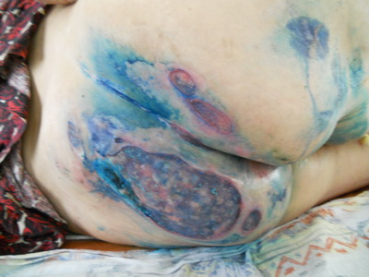 | 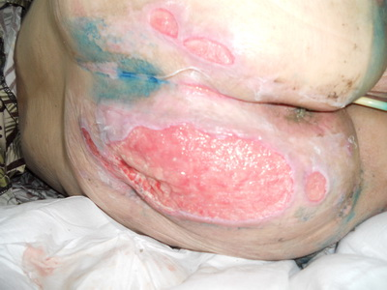
 | Wound assessment: large wounds of buttocks, wound bottom represents inflamed tissue, with no signs of tissue necrosis.  Wound toilet and dressing: wound cleansed with antiseptics (3% hydrogen peroxide, furatsilin).  VitaVallis dressing applied. | Wound assessment: wound is clean, signs of granulation tissue at the edges. Discharge is of lymphoid character.  Wound toilet and dressing: wound cleansed with antiseptics (3% hydrogen peroxide, furatsilin).  VitaVallis dressing applied.
 | Day 17 | Day 28
 | 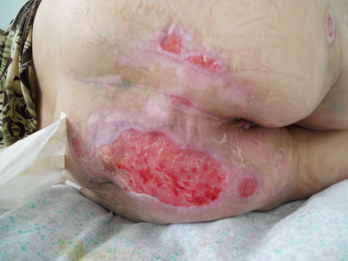 | 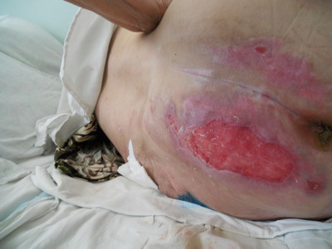
 | Wound assessment:  wounds actively granulating, size significantly reduced and evenly retracting from edges. No sign of inflammation. Phase of scarring on the right buttock.  Wound toilet and dressing:  wound cleansed with antiseptic (furatsilin).  VitaVallis dressing applied. | Wound assessment:  the right buttock wound cicatrized, the left buttock wound cuticularizing. Wound size 8 x 3 cm from the original 15 x 8 cm  Wound toilet and dressing:  wound cleansed with antiseptic (potassium permanganate).  VitaVallis dressing applied.

